- Brief summary of products
- HandTasker
Product Description
The HandTasker is an intelligent wearable rehabilitation hand system developed by the Neural Rehabilitation and Robotics Laboratory at The Chinese University of Hong Kong. Integrating soft actuation with multi-modal intention recognition technology (Brain-Computer Interface BCI/Electromyography EMG/Task Guidance), it is designed to provide precise, active hand function rehabilitation training for patients with stroke and peripheral nerve injuries. The device weighs only 100 grams and utilizes 3D printing and customizable design to fit different hand sizes and spasticity levels.
Core Technology
- Multi-mode Training System: Offers three training modes—EMG-driven, BCI intention control, and task-oriented guidance—catering to different rehabilitation stages from moderate to severe impairment.
- Dexterity Task Training: Utilizes a dedicated TaskBoard system to assist patients in performing five types of daily fine motor tasks, including cylindrical grasp, spherical grasp, and pinch grip.
- Neural Remodeling Mechanism: Forms a closed-loop of "intention recognition – motion assistance – brain feedback" based on real-time physiological signal feedback, effectively promoting functional reorganization of the motor cortex.
Clinical Validation & Certification
- Completed clinical trials involving over 100 long-term stroke patients. Data shows that over 80% of subjects achieved significant improvement in upper limb motor function (FMA-UE score) after 2-3 months (20 sessions) of training (p<0.01), with sustained therapeutic effects.
- Listed in the U.S. FDA medical device database and holds EU CE Mark certification (Class I medical device).
- Selected for the 2025 Tencent Silver Tech Partners Program, with an application demonstration scheduled for deployment in a Shanghai nursing home in 2026.
Market Application
Currently deployed in over 40 public/private hospitals, rehabilitation centers, and special needs schools in Hong Kong (e.g., Eastern District Hospital, Union Hospital, Hong Kong Red Cross schools), serving over 300 patients cumulatively. The product has also entered overseas markets such as Pakistan through the "Belt and Road" Rehabilitation Alliance Support Program, with applications in Macao rehabilitation centers, multiple public hospitals in Mainland China (research collaboration), and hospitals in Pakistan (clinical partnership).
- XoBrace
Product Description
The XoBrace is the world's first wearable joint-assist robot utilizing soft fabric and dynamic air-cell technology. Its development originated from the clinical need to help children with cerebral palsy regain standing and walking abilities. The product line has now evolved to offer both therapeutic efficacy and a consumer-grade experience, covering multiple scenarios, including cerebral palsy rehabilitation, postoperative support, and sports protection.
Core Technology
- Dynamic Pneumatic Actuation System: Provides compliant, soft assistance aligned with joint movement trajectories through precise air-cell pressure regulation, eliminating the risk of secondary injury associated with rigid exoskeletons.
- Lightweight & Breathable Design: Employs 3D knitting technology to ensure comfort for extended wear while delivering effective support.
Clinical Validation & Certification
- The pediatric rehabilitation version has completed pre-clinical studies involving children with cerebral palsy. A case study showed a 3-year-9-month-old child with cerebral palsy progressed from being unable to stand independently to achieving stable standing after 15 XoBrace training sessions, with qualitative improvement in walking ability after 20 sessions.
- The adult sports knee brace version was officially launched at the Hong Kong International Medical and Healthcare Fair in May 2024.
Market Application
- Consumer version: As a sports knee brace, providing daily protection and support for sports enthusiasts, post-operative joint recovery patients, and the elderly with degenerative joint issues.

- XoMuscle
Product Description
The XoMuscle is a revolutionary high-performance biomimetic artificial muscle technology whose key performance metrics (stress, strain, power density) surpass those of human skeletal muscle. As the core actuation unit for next-generation wearable rehabilitation robots, it is designed to provide powerful "garment-like" dynamic assistance for major body joints, helping patients with severe dysfunction regain activities of daily living.
Core Technology
- Superior Performance Metrics: Power-to-weight ratio exceeds that of natural muscle by 200 times, with a response speed 20 times faster than human muscle, while maintaining a high safety margin due to its soft nature.
- Biomimetic Structure & Customization: Can be fabricated to match any human muscle morphology, enabling multi-joint coverage from fingers to torso.
- System Integration: Seamlessly interfaces with BCI systems to achieve precise assistance aligned with user intention.
R&D Progress & Roadmap
- The Technology Readiness Level (TRL) reached 6-7. Prototype development and engineering testing for multiple joints (wrist, elbow, hip) have been completed.
- Pre-clinical studies for upper- and lower-limb assistance in stroke patients are underway. Preliminary data indicate improvements in walking speed and balance exceeding 50%.
- Multiple international invention patents have been filed, and the technology won the Gold Medal at the 2023 International Exhibition of Inventions of Geneva.
Market Positioning & Outlook
As a platform technology, XoMuscle is the company's core future-facing product, planned for application in:
- Advanced Neurorehabilitation: Providing whole-body motor function reconstruction solutions for stroke and spinal cord injury patients.
- Human Performance Augmentation: Expanding into occupational fields requiring physical assistance, such as logistics and nursing.
- Innovative Research Collaboration: Exploring new human-machine integration scenarios in partnership with top global research institutions.

- Pictures of each product
- HandTasker
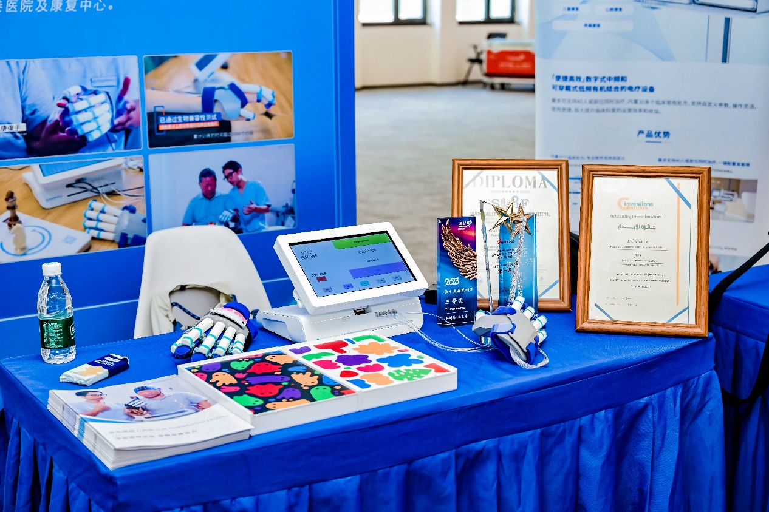

- XoBrace
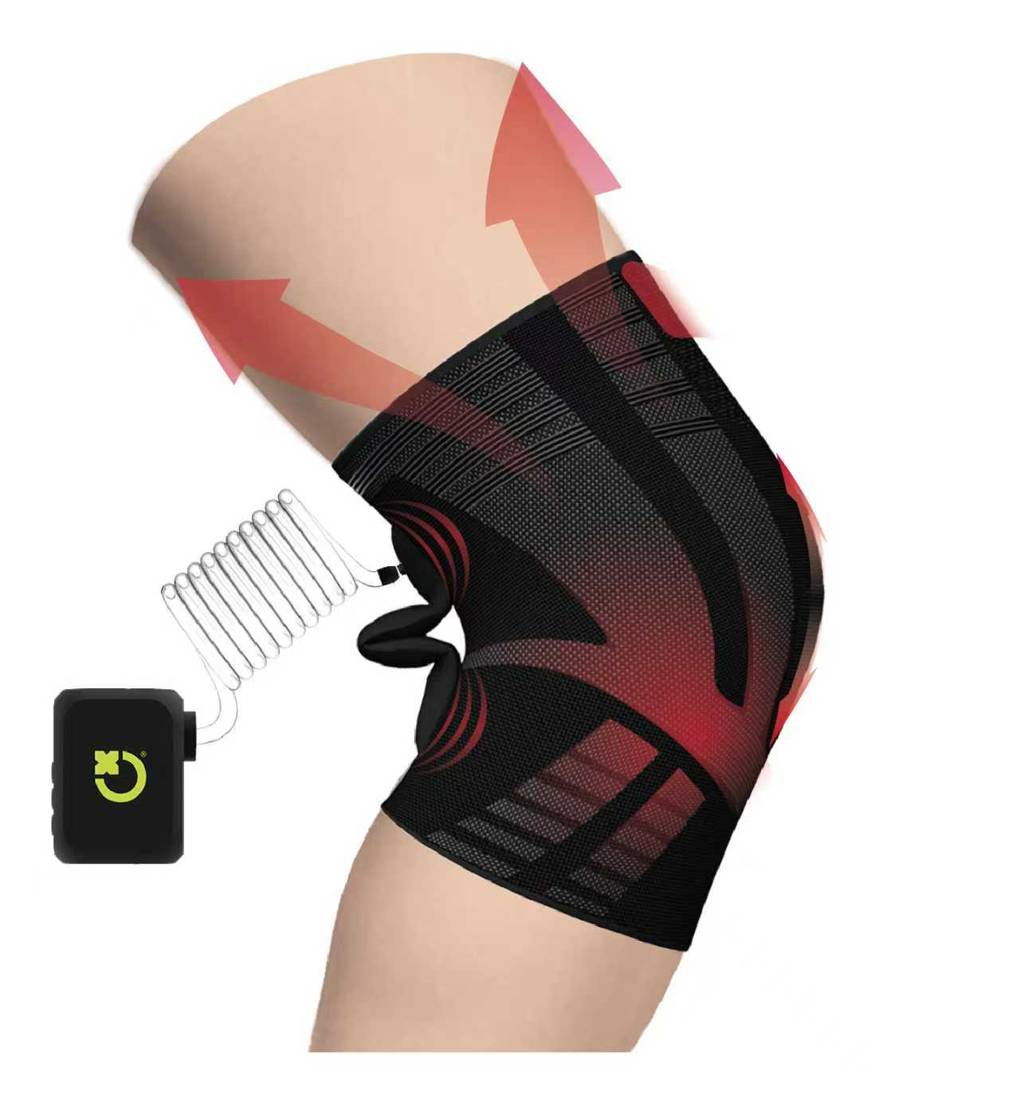

- XoMuscle (Upper limb)
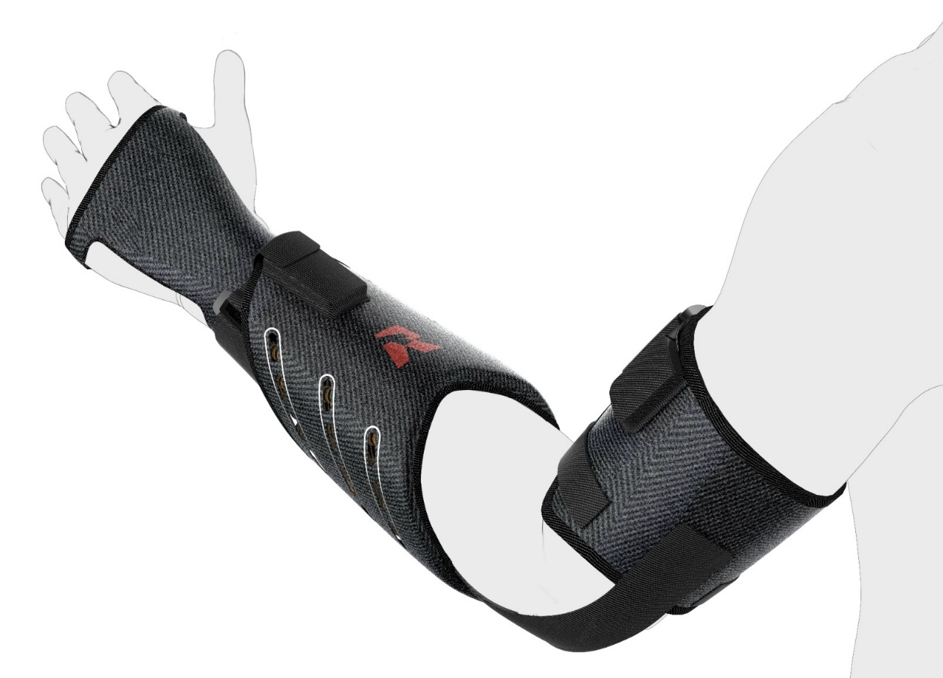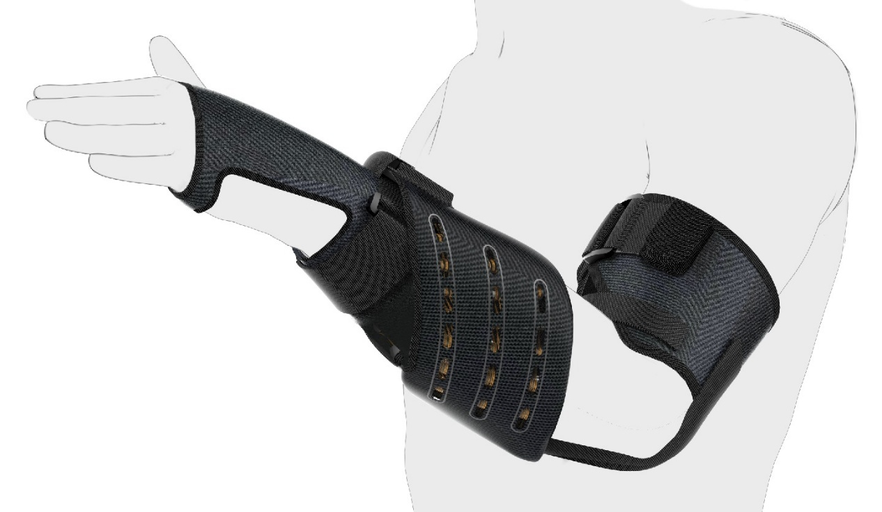

- XoMuscle (Lower limb)
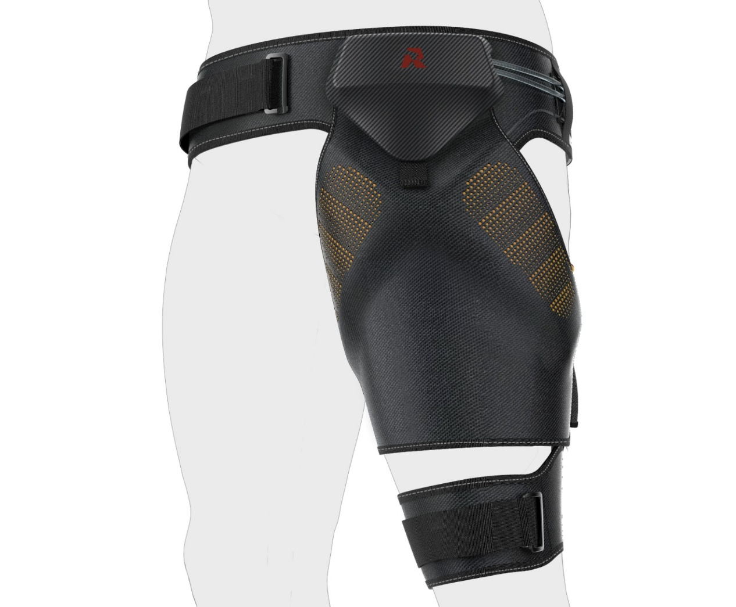

- List of the events/exhibitions that you participate in and present your products, including the dates and in which country

- Gold Medical, iENA International Trade Fair ”Ideas-Inventions-New Products.” Nov 2025 (Nuremberg, Germany)
- Gold Medal, Silicon Valley International Invention Festival, May 2024 (USA)
- Gold Medal, Geneva international exhibition of inventions, March 2023 (Geneva, Switzerland)
- Asia Summit on Global Health (ASGH), May 2022, 2023, 2024, 2025 (Hong Kong)
- The Hong Kong International Medical and Healthcare Fair, May 2022, 2023, 2024, 2025 (Hong Kong)
- The Gerontech and Innovation Expo cum Summit (GIES), Nov 2022, 2023, 2024, 2025 (Hong Kong)
- The Golden Age Expo and Summit, Jul 2024, 2025 (Hong Kong)
- The 7th China International Import Expo, Aug 2024 (Shanghai, China)
- NovaX International Venture Carnival, Aug 2024 (Hong Kong)
- Asia Pacific Stroke Conference 2023, May 2023 (Hong Kong)
- Rehabilitation Technology Fun Day (Hong Kong Science Museum), Mar 2023 (Hong Kong)
- Business of IP Asia Forum (BIP ASIA), Oct 2022 (Hong Kong)
- Rehabilitation workshop held by the Chinese Manufacturers’ Association of Hong Kong (CMA) Apr 2025
- 1st Prize, the GBA University Sci-Tech Investment Conference (AI & Robotics), Jun 2025 (Zhuhai, China)
- Product showcase & training event, held by Pamela Youde Nethersole Eastern Hospital (Hong Kong)

